**Practice Problem 1**

**Business Rules:**

ABC Corporation has five departments: administration, marketing, sales, shipping, and purchasing. Each department employs many employees. Each employee has an ID, a name, a home address, a home phone number, a salary and Social Security number. Some employees are classified as sales representatives, some as technical support, and some as administrators. Sales representatives receive a commission based on sales. Technical support employees are required to be certified in their areas of expertise. All administrators have a title and a bonus. Given that information, create the EERD containing all primary keys, foreign keys, and main attributes.

* Each department employs many employees; it is a 1:M relationship. The relationship between department and employee is mandatory and dependent on the many side as employees must belong to a department.
* Every employee has an ID, name, home address, home phone number, salary and social security number. These are attributes. An ID and a social security number are unique identifiers.
* Some employees are sales representatives; this is a 0:1 relationship as not all employees are sales representatives. All sales representatives are employees; this is mandatory on the side of the sales rep and optional on the employee side. It is not stated that employees can or cannot belong to technical support or administrators, so it is assumed to be a unique entity. (Condition is true for tech support and administrators.) Every sales representative receives a commission; this is an attribute. A commission may or may not be unique to the sales representative.
* Some employees are technical support. This is a 0:M relationship. Every technical support employee has a certification. Certification is an attribute. The business case does not state that tech support employees may have more than one certification.
* Some employees are administrators. This is a 0:M relationship. Every administrator has a title and receives a bonus. Titles and bonuses are attributes. It is not stated that titles and/or bonuses are unique or non-unique.

**In addition, be prepared to provide an explanation for each business rule as follows:**

"A relationship between customer and purchase (see above) is 1:M as every customer may have many purchases and each purchase belongs to only one customer. The relationship is optional on the “many” side because business rules say that every customer “may” have a purchase. It is mandatory on the “one” side because business rules say that every purchase “must” belong to a customer. According to business rules the cardinality on the many side is (0, N) because it is optional and (1, 1) for the one side because it is mandatory. A weak relationship will be used as purchases are not dependent on customers. "

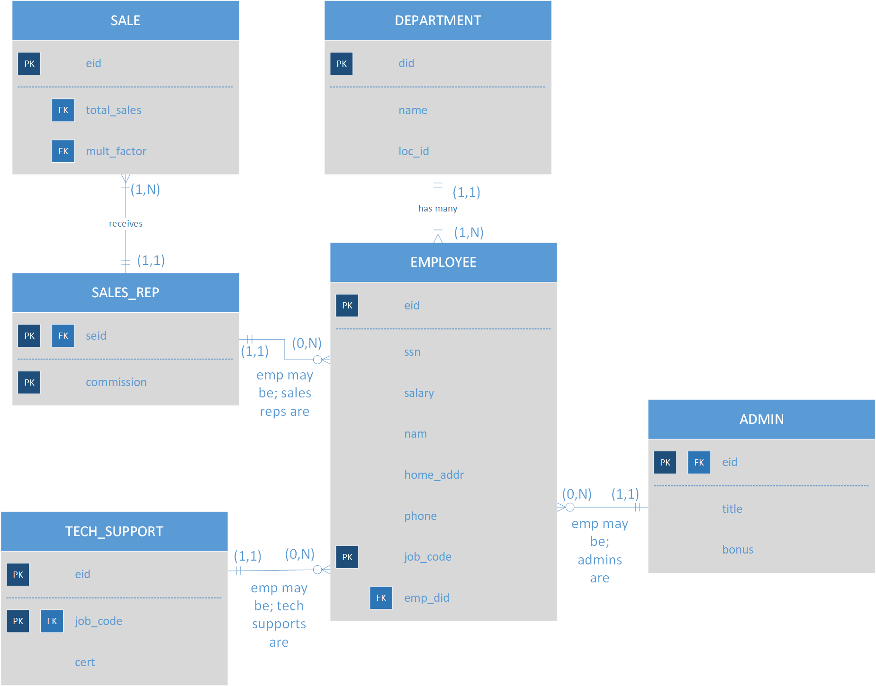

**Practice Problem 2**

**Business Rules:**  
During peak periods, Temporary Employment Corporation (TEC) places temporary workers in companies. TEC’s manager gives you the following description of the business:

* + TEC has a file of candidates who are willing to work and a list of companies that request temporaries.
  + If the candidate has worked before, that candidate has a specific job history. Each time the candidate worked, one additional job history record was created.
  + Each candidate has earned several qualifications. Each qualification may be earned by more than one candidate.
  + Each time a company requests a temporary employee, TEC makes an entry in the Openings folder. That folder contains an opening number, a company name, required qualification, a starting date, an anticipated ending date, and hourly pay.
  + Each opening requires only one specific or main qualification.
  + When a candidate matches the qualification, (s)he is given the job and an entry is made in the Placement Record folder. That folder contains an opening number, a candidate number, the total hours worked, etc. In addition, an entry is made in the job history for the candidate.
  + An opening can be filled by many candidates, and a candidate can fill many openings.

